
Chesterton Community Sports College
Mathematics Department


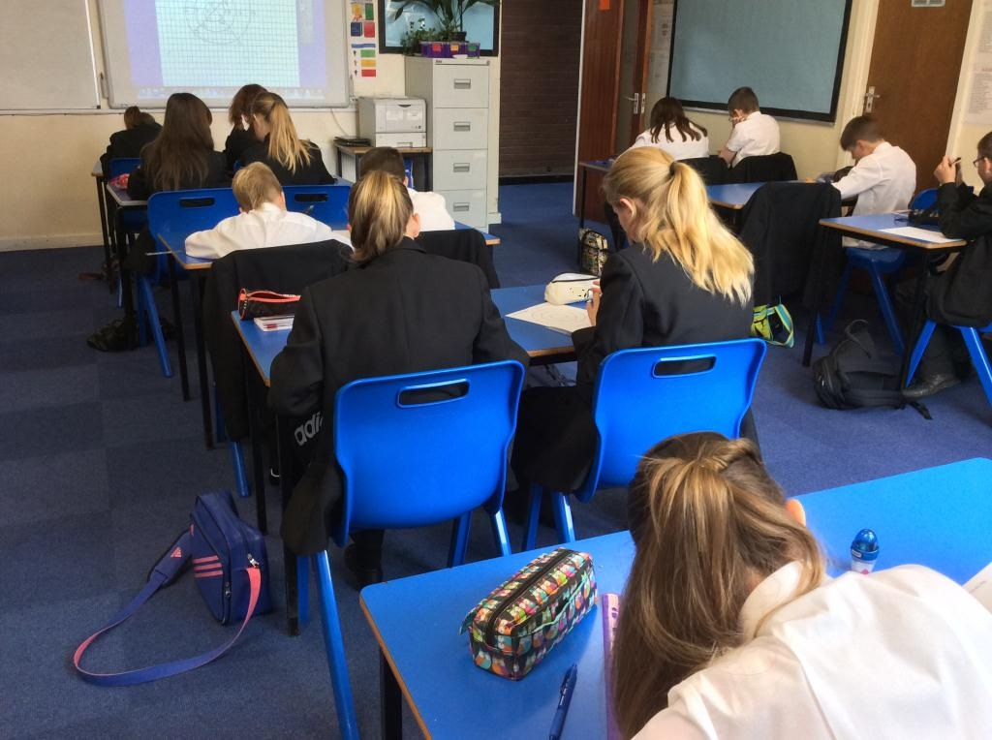
The mathematics department is extremely hardworking and committed to every child achieving their potential. It is very successful with rapid improvements in results over recent years. GCSE results are excellent with 81% of year 11 achieving grade C or above in 2015. Results have been consistently good in recent years with 79%, 80%, 78% and 86%, 81% pass rates in 2010, 2011, 2012, 2013 and 2014 respectively and these are well above national average. Progress measures are also excellent.
Many pupils also take GCSE Statistics and the year group of 2015 achieved a 96% pass rate at grade C or above with 19% achieving A and A*.
The department currently uses the GCSE Edexcel A Course for maths with virtually all students taking the higher tier. The statistics course is also with Edexcel, which is studied in year 10 for a term.
The mathematics rooms are well equipped, have stimulating displays and provide an excellent learning environment. The mathematics curriculum is enriched with many extra curricular activities including a Maths Club for year 7 and 8 pupils, Booster Classes for GCSE students, competitions, puzzles and visits to Keele University Maths Department. The Half Term Study days provided immediately before key GCSE exams are always appreciated and well attended.
The department has delivered exciting and innovative projects as part of Creative Learning Week which in 2015 included collaborative projects with both the History and Technology departments.
Successes have been achieved in the UK Mathematics Challenges at both Junior and Intermediate Levels with Gold, Silver and Bronze awards all being gained.
Mathematics is a strong, innovative and forward thinking core subject department, ready to meet the challenges posed by the evolving modern education system.

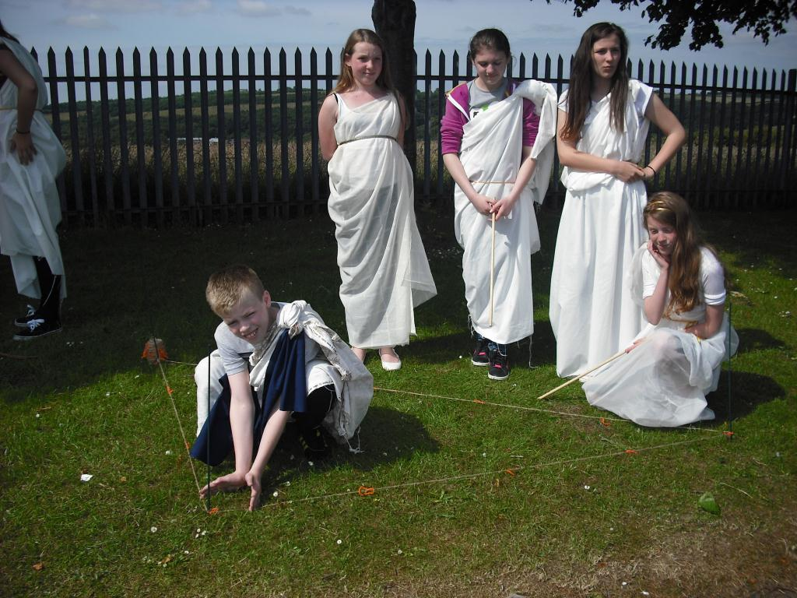
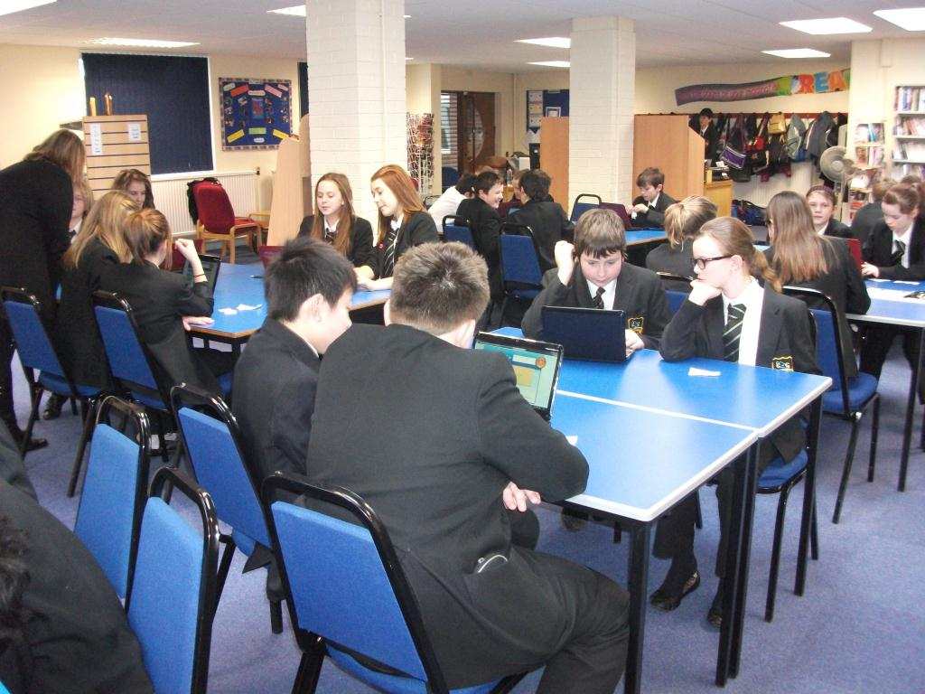
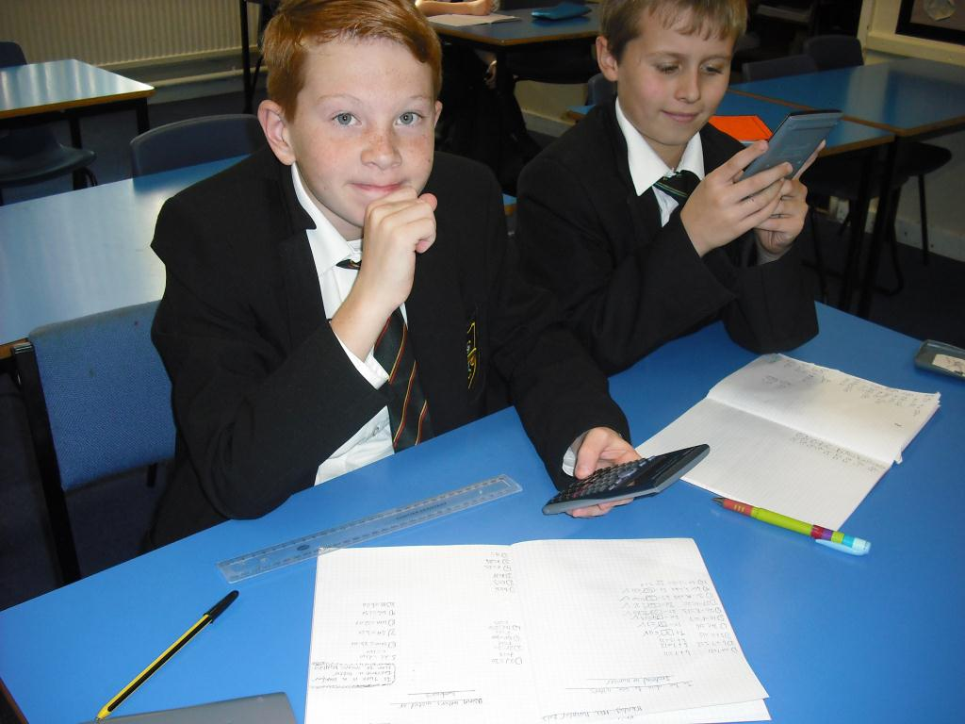
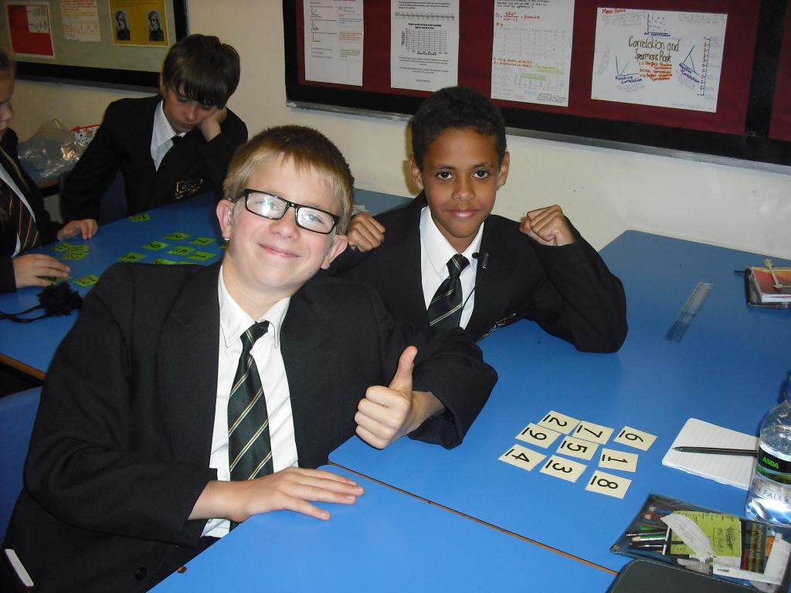
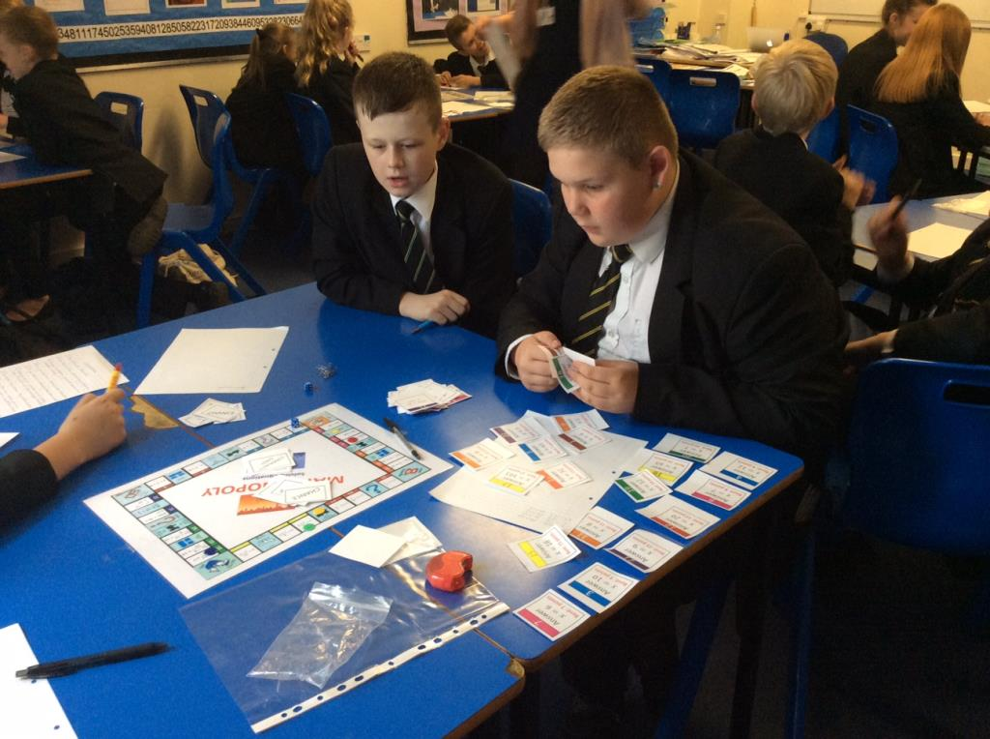
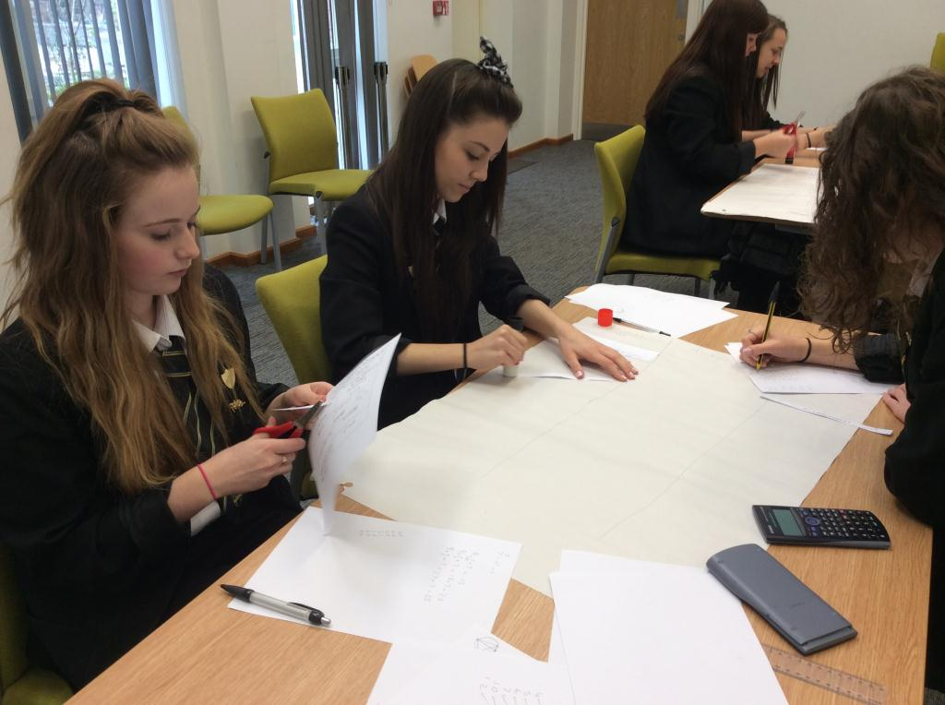
Achieving 96%, Grade A* to C GCSE Statistics
Success in the Mathematics Department
Grade A* to C GCSE Mathematics Achieving 80% and above

